 | Sinhgad Technical Education Society’s  RMD Sinhgad School of Engineering, Warje, Pune.  Department of Electronics & Telecommunication Engineering.

Name of Student | Aditya Ravindra Ghayal
Division | A
Roll Number | 23
Experiment Title | MIMO Channel Coefficient
Marks

 | Sinhgad Technical Education Society’s  RMD Sinhgad School of Engineering, Warje, Pune.  Department of E&TC Engineering | Expt.No.  6
Title | MIMO Channel Coefficient

Aim
Estimate channel coefficient vector Multi-Antenna Systems.

Apparatus
PC, Octave

Theory
Two flavors of MIMO implementation – spatial multiplexing and spatial diversity – were discussed in the previous article. In that, it was mentioned that the reliability of a MIMO system is governed by diversity and the capacity of the link is governed by degrees of freedom.

Channel State Information (CSI)
Multiple data streams can be spatially multiplexed over the M transmit antennas and are received by the N receiver antennas. Spatially multiplexing increases the capacity of the link, since multiple data streams are transmitted over the same available frequency band. On the other hand, antenna diversity systems (dubbed as MIMO using diversity) merely improve the reliability of the link.
But the question of whether the transmission of multiple streams of data over multiple antenna really works, depends on the actual geometry of the antenna systems. Transmission of independent data streams over multiple antennas depends on the correlation factor that measures the influence of the spatially separated signals over each other. One way to eliminate correlation (there by mutual influence of spatially separated signals) is to use orthogonally polarized antennas (one antenna is horizontally polarized and the other is vertically polarized) that sufficiently separate the signals in spatial dimension.
Finally, the transmission matrix (also called Channel State Information (CSI)) determines the suitability of MIMO techniques and influences the capacity to a great extent. In a SISO channel, the channel state information is constant and does not change from bit to bit. Thus, the knowledge of CSI in a SISO link is often not needed as it is characterized by steady state SNR. In the case of rapid fading channels, the channel state information varies rapidly, and we may think of employing MIMO to break the channel variations into spatially separated sub channels. Thus, the knowledge channel state information (at transmitter or receiver) will open up the possibility of incorporating this information in intelligent system design.
In a MIMO configuration, a typical CSI matrix is formed by transmitting a symbol (say value ‘1’) from each of the transmitting antenna and its response on the multiple receiving antennas are noted. For example, in a 3$×$3 configuration, at some time instant, we transmit the voltage ‘1’ from the first antenna and record its response on the three receiving antennas. Let’s say the three receiver antennas picks up the following voltage values – [0.8, 0.7, 0.9].
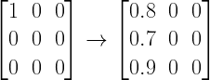
At the same time instant, the procedure is repeated for other transmit antennas and the response of multiple receive antennas are recorded. A complete CSI matrix is shown below
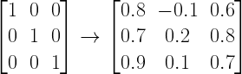
In this method, the transmitter transmits the data blindly and the receiver constructs the CSI matrix. This method of transmission is called open loop transmission scheme and are not generally effective. From the sample CSI matrix above, it can be noted that the transmission through antenna 2 is not effective (note the low voltage values recorded at the receiver antennas (second column on the right)) the receiver may feedback the CSI matrix to the transmitter and the transmitter may decide not to transmit on antenna 2, thereby saving power. This is an example for closed loop diversity scheme. In this way the knowledge of CSI opens up the possibility for intelligent communication.
The CSI matrix shown above contain only real numbers that describe the amplitude variations. In reality the CSI matrix contains elements that are complex, and they describe both the amplitude and phase variations of the link.
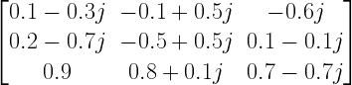

MIMO channel Model
A channel model is needed to properly assess a MIMO channel. In MIMO, the system configuration typically contains M antennas at the transmitter and N antennas at the receiver front end as illustrated in the following figure.
Here, each receiver antenna receives not only the direct signal intended for it, but also receives a fraction of signal from other propagation paths. Thus, the channel response is expressed as a transmission matrix H. The direct path formed between antenna 1 at the transmitter and the antenna 1 at the receiver is represented by the channel response $h_{11}$. The channel response of the path formed between antenna 1 in the transmitter and antenna 2 in the receiver is expressed as $h_{21}$ and so on. Thus, the channel matrix is of dimension N$×$M.
The received vector y is expressed in terms of the channel transmission matrix H, the input vector x and noise vector n as

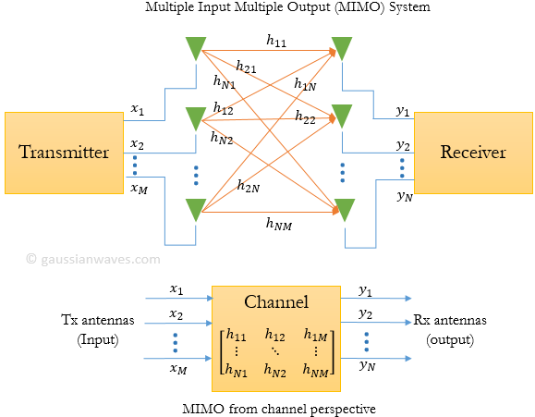

where the various symbols are
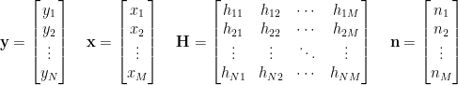
Note that the response of the MIMO link is expressed as a set of linear equations. For a simple 2$×$2 MIMO configuration, the received signal vector is expressed as
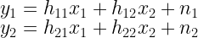
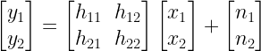
The receiver has to solve this set of equations to find out what was transmitted x. The stability of the solution depends on the condition number of the transmission matrix H (CSI).

 | Sinhgad Technical Education Society’s  RMD Sinhgad School of Engineering, Warje, Pune.  Department of E&TC Engineering | Expt.No.  6
Title | MIMO Channel Coefficient
 | Student Worksheet

Problem Statement
Suppose NT = NR = 2. Generate the elements of the channel matrix H for a Rayleigh fading AWGN channel given the corresponding inputs to the detectors for the two receive antennas as [3.0691+0.24416i;1.184-0.039403i]

Formulae
The elements of Hare $h_{11},h_{12},h_{21},h_{22}$. For the Rayleigh fading channel, these parameters are complex-valued, statistically independent, zero-mean Gaussian random variables with identical variances $σ_{h}^{2}$. Hence, the two inputs to the detectors for the two antennas are
$$Y_{1}=h_{11}s_{1}+h_{12}s_{2}+η_{1}$$
$$Y_{2}=h_{21}s_{1}+h_{22}s_{2}+η_{2}$$
where s1 and s2 are the transmitted symbols from the two transmit antennas and ($η_{1},η_{2}$) are the statistically independent additive Gaussian noise terms with zero mean and equal variances $σ_{n}^{2}$ .

Conclusion
Once the channel coefficients are computed, these can be used by receiver to solve this set of equations to find out what was transmitted. Solving a set of linear equation has problems associated with rounding effects and how bad a matrix is. Storage of coefficients in computer memory is prone to fixed point effects or rounding.

Review Questions
- What are Rayleigh fading channels?
- What is the difference between AWGN and Rayleigh fading channel?
- What is Rayleigh fading and its solution?
- How do you model for fading channel?

 | Sinhgad Technical Education Society’s  RMD Sinhgad School of Engineering, Warje, Pune.  Department of E&TC Engineering | Expt.No.  6
Title | MIMO Channel Coefficient
Name
Roll No.

Program
- Nt = 2; % No. of transmit antennas
- Nr = 2; % No. of receive antennas
- No = 1; % Noise variance
- y = input('Enter received signal coefficients at the detector = ');
- s = 2*randi([0 1],Nt,1) - 1; % Binary transmitted symbols
- %H = (randn(Nr,Nt) + 1*i*randn(Nr,Nt))/sqrt(2) % Channel coefficients
- %disp ('Channel coefficients are:');
- %disp(H);
- noise = sqrt(No/2)*(randn(Nr, 1) + 1*i*randn(Nr,1 )); % AWGN noise
- %y = H*s + noise; % Inputs to the detectors
- H = (y - noise) / s ;
- disp(' The channel coefficients are: ');
- disp(H);

Output
Enter received signal coefficients at the detector = [3.0691+0.24416i;1.184-0.039403i]
The channel coefficients are:
-1.6227 - 0.3860i -1.6227 - 0.3860i
0.0475 + 0.6100i 0.0475 + 0.6100i
>>

